CS 484 Introduction to Machine Learning

Spring 2021 Midterm Test

# Instruction

1. Calculate your answers using all the available precision
2. If the final numeric answer has more than four decimal places, then round the numeric answer to the nearest fourth decimal place. Otherwise, please give the exact value.
3. You can attempt this test once.

# Question 1 (5 points)

Which of the following statement(s) best describes Machine Learning?

Multiple Choice:

1. Machine learning is an automated process that uses algorithms to identify patterns within data, and those patterns are then used to create a data model that can make predictions.
2. Machine learning is an idea that systems can learn from data, identify patterns, and make decisions with minimal human intervention.
3. A computer program is said to learn from experience E for some task T and some performance measure P, if its performance on T, as measured by P, improves with experience E. Machine learning refers to the field of study concerned with these programs or systems.
4. All the Above
5. None of the Above

# Question 2 (5 points)

What does the term Label mean in the context of Machine Learning?

Multiple Choice:

1. A cute sticker that is affixed to the hardware on where the machine learning process is running.
2. A user-defined name that is attached to a version of your machine learning computer codes.
3. A system-level command that creates, changes, or deletes a logical label on your dataset.
4. A label is what a machine learning algorithm will predict or forecast. Put it another way, it is the target or response field.
5. There is no such term in the context of Machine Learning.

# Question 3 (5 points)

Suppose the itemset {A, B, C, D, E} has a Support value of 1, then what is the Lift value of this rule {B, D} ➔ {A, C, E}?

Multiple Choice:

1. 0
2. 0.5
3. 1
4. 2
5. Cannot be Determined

# Question 4 (5 points)

We have generated the following scatterplot of two fields 𝑥 and 𝑦. Suppose we are going to perform the K-means clustering analysis on the data in the scatterplot. Which of the following statements is valid about the Silhouette value for the 4-cluster solution?

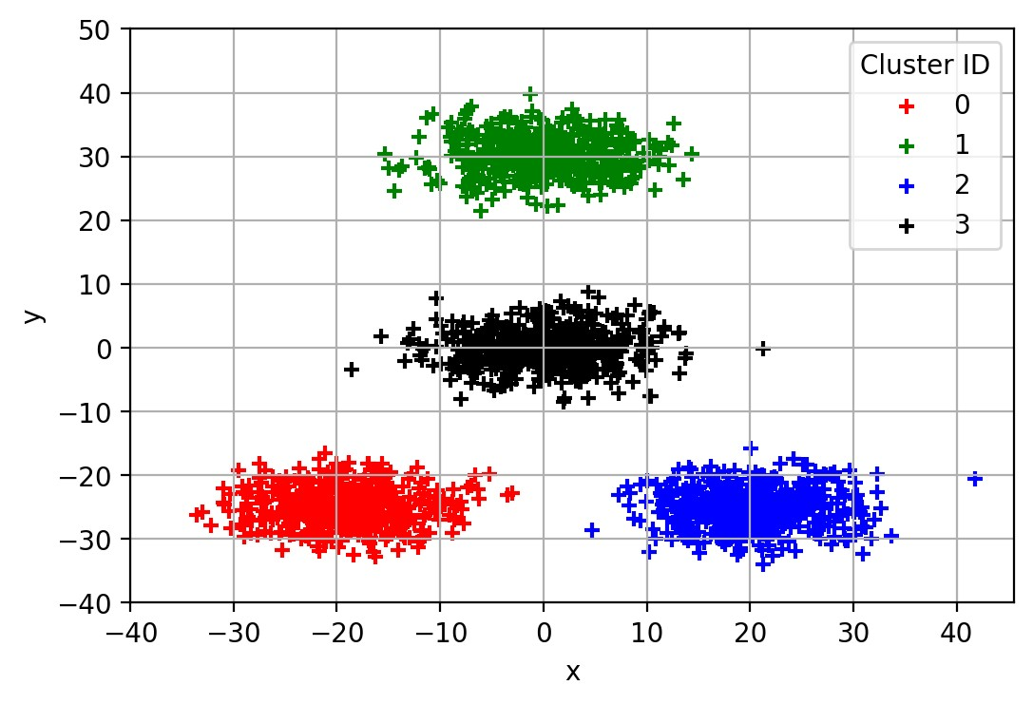

1. Close to the negative one
2. About zero
3. Close to one
4. Close to four
5. Cannot be determined

# Question 5 (5 points)

Suppose there are 100 unique items in the universal set, how many 5-itemset can we possibly generate?

1. 100
2. 120
3. 75,287,520
4. 9,034,502,400
5. 1,267,650,600,228,229,401,496,703,205,375

# Question 6 (5 points)

Suppose we train a classification tree on a nominal target field that has four categories. What is the highest possible Entropy value that we can see in any node?

1. 0
2. 0.5
3. 0.75
4. 1.0
5. 2.0

# Question 7 (5 points)

The file 100Values.csv contains 100 numeric values. Use the Shimazaki and Shinomoto (2007) method and try 𝑑 = 0.1, 0.2, 0.5, 1.0, 2.0, and 5.0. What will you recommend for the histogram bin width?

# Question 8 (5 points)

I invited ten friends to my home to watch a basketball game. My friends brought snacks and beverages along. The following table lists the items my friends brought.

|  |  |
| --- | --- |
| Friend | Items |
| Andrew | Cheese, Cracker, Salsa, Soda, Tortilla, Wings |
| Betty | Cheese, Soda, Tortilla, Wings |
| Carl | Cheese, Ice Cream, Soda, Wings |
| Danny | Cheese, Ice Cream, Salsa, Tortilla, Wings |
| Emily | Pizza, Salsa, Soda, Tortilla, Wings |
| Frank | Cheese, Cracker, Ice Cream, Soda, Wings |
| Gary | Cracker, Tortilla |
| Henry | Ice Cream, Pizza, Tortilla |
| Irene | Cheese, Cracker, Soda |
| Jack | Cheese, Cracker, Pizza, Salsa, Wings |

I noticed that a few of my friends brought Cheese, Soda, and Wings together. Since I prefer to spend your money on other food besides Wings, I am curious to know how likely my friends will bring Wings if they have already brought Cheese and Soda. Therefore, please help me determine the Lift of this association rule {Cheese, Soda} ==> {Wings}.

# Question 9 (5 points)

Suppose we trained a classification tree using 5,000 observations. The target field has five categories whose frequencies are listed below. What is the Gini Index value of the root node?

|  |  |  |  |  |  |
| --- | --- | --- | --- | --- | --- |
| **Target Category** | I | II | III | IV | V |
| **Frequency** | 262 | 1,007 | 1,662 | 1,510 | 559 |

# Question 10 (5 points)

We observed 5,000 observations for a target field that has five categories. The categories are I, II, III, IV, and V. The following table shows their frequencies. We trained a multinomial logistic model that contains only the Intercept terms.

Suppose the reference target category is Category III. What is the estimated Intercept of Category V?

(Hint: Suppose the 𝐽th target category is the reference category of the target field, then a model that

𝜋𝑖𝑗 contains only the Intercept terms theory has this formulation: log𝑒 (𝜋𝑖𝐽) = 𝜷𝑗 for 𝑗 = 1, … , 𝐾. Think of an intuitive way to estimate the probabilities and solve for the Intercept terms.)

|  |  |  |  |  |  |
| --- | --- | --- | --- | --- | --- |
| **Target Category** | I | II | III | IV | V |
| **Frequency** | 262 | 1,007 | 1,662 | 1,510 | 559 |

# Questions 11 and 12

We performed a cluster analysis with the Chebyshev distance on a data that has five interval variables.

We found two clusters and the following table shows the cluster centroids.

|  |  |  |  |  |  |
| --- | --- | --- | --- | --- | --- |
| Cluster | X1 | X2 | X3 | X4 | X5 |
| 0 | 6.34 | 6.82 | 7.21 | 7.18 | 7.47 |
| 1 | 8.04 | 8.56 | 9.42 | 8.08 | 7.70 |

We now have a new observation: X1 = 9.7, X2 = 10.7, X3 = 11.4, X4 = 7.8, and X5 = 6.5.

Question 11 (5 points)

Which cluster should we assign this new observation to?

Question 12 (5 points)

Also, what is the Chebyshev distance from the new observation to the assigned Cluster?

# Questions 13, 14, and 15

We are going to train a classification tree on 5,000 observations. We will use the Entropy criterion for growing the tree. The target field has five categories, namely, A, B, C, D, and E. The ordinal feature has four categories where I < II < III < IV. Instead of a casewise dataset, the data have been aggregated and shown in the following table.

|  |  |  |  |  |  |
| --- | --- | --- | --- | --- | --- |
|  |  | Target Field | |  |  |
| Feature | A | B | C | D | E |
| I | 65 | 304 | 530 | 487 | 140 |
| II | 74 | 185 | 160 | 55 | 16 |
| III | 33 | 228 | 623 | 755 | 363 |
| IV | 90 | 290 | 349 | 213 | 40 |

# Question 13 (5 points)

Which is the optimal split in the first layer of the classification tree?

Multiple Choice:

1. {I} + {II, III, IV}
2. {I, II} + {III, IV}
3. {I, II, III} + {IV}
4. None of the Above

# Question 14 (5 points)

Suppose we continue to split the first layer and create the second layer. What is the optimal split in the second layer?

Multiple Choice:

1. {I} + {II, III}
2. {I, II} + {III}
3. {II, III} + {IV}
4. {II} + {III, IV}
5. None of the Above

Question 15 (5 points)

What is the Misclassification Rate of this two layers classification tree?

# Question 16 (5 points)

You are going to build a logistic model using the 20 observations below. The binary target field is y, and the interval predictor is x.

|  |  |  |  |  |  |  |  |  |  |  |  |  |  |  |  |  |  |  |  |  |
| --- | --- | --- | --- | --- | --- | --- | --- | --- | --- | --- | --- | --- | --- | --- | --- | --- | --- | --- | --- | --- |
| x | 0 | 0 | 0 | 0 | 1 | 1 | 1 | 1 | 2 | 2 | 2 | 2 | 3 | 3 | 3 | 3 | 4 | 4 | 4 | 4 |
| y | 0 | 0 | 0 | 0 | 0 | 0 | 0 | 0 | 0 | 0 | 0 | 1 | 0 | 0 | 1 | 1 | 0 | 1 | 1 | 1 |

The specifications are:

1. The target event category is 1
2. The Intercept term is included
3. The optimization method is Newton 4. The maximum number of iterations is 100

5. The tolerance level is 1e-8.

After you have built your model, you will apply them to the following test data and then calculate the misclassification rate metric. An observation will be classified as an event if the predicted event probability is greater than or equal to 0.3.

|  |  |  |  |  |  |
| --- | --- | --- | --- | --- | --- |
| x | 0 | 1 | 2 | 3 | 4 |
| y | 1 | 0 | 1 | 0 | 1 |

What is the Misclassification Rate when the Logistic model is applied to the test data?

# Questions 17 and 18

You can use Chicago’s 311 Service Request to report street potholes. After a request has been received, the Department of Transportation will first assess the severity of the pothole, and then schedule a road crew to fill up the pothole. After the pothole is filled, the service request will be closed.

You are provided with this CSV file **ChicagoCompletedPotHole.csv** for analyzing the city’s efforts to fill up street potholes. The data contains 17,912 observations. Each observation represents a completed request which was created between December 1, 2017, and March 31, 2018, and was completed between December 4, 2017, and September 12, 2018. The data has the following seven variables.

|  |  |  |
| --- | --- | --- |
| **Name** | **Level** | **Description** |
| 1) CASE_SEQUENCE | Nominal | A unique index for identifying an observation |
| 2) WARD | Nominal | Chicago’s ward number from 1 to 50 |
| 3) CREATION_MONTH | Nominal | Calendar month when the request was created |
| 4) N_POTHOLES_FILLED_ON_BLOCK | Interval | Number of potholes filled on the city block |
| 5) N_DAYS_FOR_COMPLETION | Interval | Number of days elapsed until completion |
| 6) LATITUDE | Interval | Latitude of the city block |
| 7) LONGITUDE | Interval | Longitude of the city block |

You will use the K-Means Clustering algorithm to identify clusters in the entire data with the following specifications.

1. Use loge(N_POTHOLES_FILLED_ON_BLOCK), loge(1 + N_DAYS_FOR_COMPLETION), LATITUDE, and LONGITUDE (i.e., you need to perform the transformations before clustering)
2. The maximum number of clusters is 10 and the minimum number of clusters is 2
3. The random seed is 20201014
4. Use both the Elbow and the Silhouette methods to determine the number of clusters

Question 17 (5 points)

What is the optimal number of clusters? Please give the number of clusters as an integer.

Question 18 (5 points)

What is the Davies-Bouldin score for that optimal number of clusters?

# Questions 19 and 20

In the automobile industry, a common question is how likely a policyholder will file a claim during the coverage period. You will analyze the **policy_2001.csv** that contains data on 617 policyholders. We will use only the following variables.

**Target Variable**

* CLAIM_FLAG: Claim Indicator (1 = Claim Filed, 0 = Otherwise) and 1 is the event value.

**Nominal Predictor**

* CREDIT_SCORE_BAND: Credit Score Tier (‘450 – 619’, ‘620 – 659’, ‘660 – 749’, and ‘750 +’)

## Interval Predictors

* BLUEBOOK_1000: Blue Book Value in Thousands of Dollars (min. = 1.5, max. = 39.54)
* CUST_LOYALTY: Number of Years with Company Before Policy Date (min. = 0, max.  21)
* MVR_PTS: Motor Vehicle Record Points (min. = 0, max. = 10)
* TIF: Time-in-Force (min. = 101, max. = 107)
* TRAVTIME: Number of Miles Distance Commute to Work (min. = 5, max.  93)

You will train a multinomial logistic model according to the following specifications.

* The optimization algorithm is the Newton-Raphson method
* The maximum number of iterations is 200
* The relative error in parameter estimates acceptable for convergence is 1E-8
* The Intercept term must be included in the model
* Use the All Possible Subset method to search for the optimal model.

Question 19 (5 points)

Based on the Akaike Information Criterion, which predictors are selected into the final logistic model?

# Question 20 (5 points)

What is the Bayesian Information Criterion value of the final logistic model?